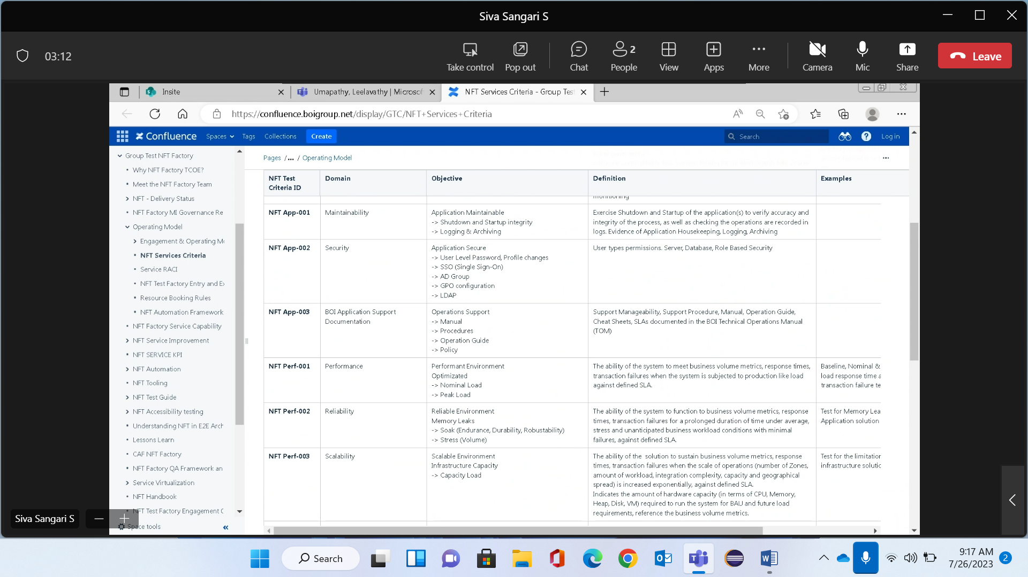 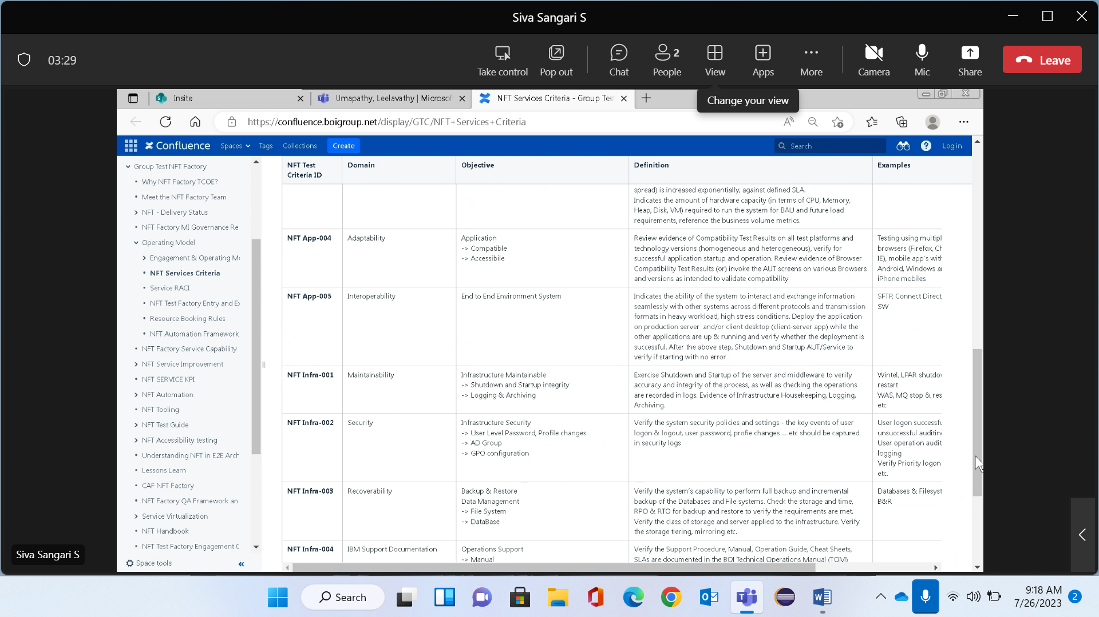

assess the features like reliability and recoverability of the application. 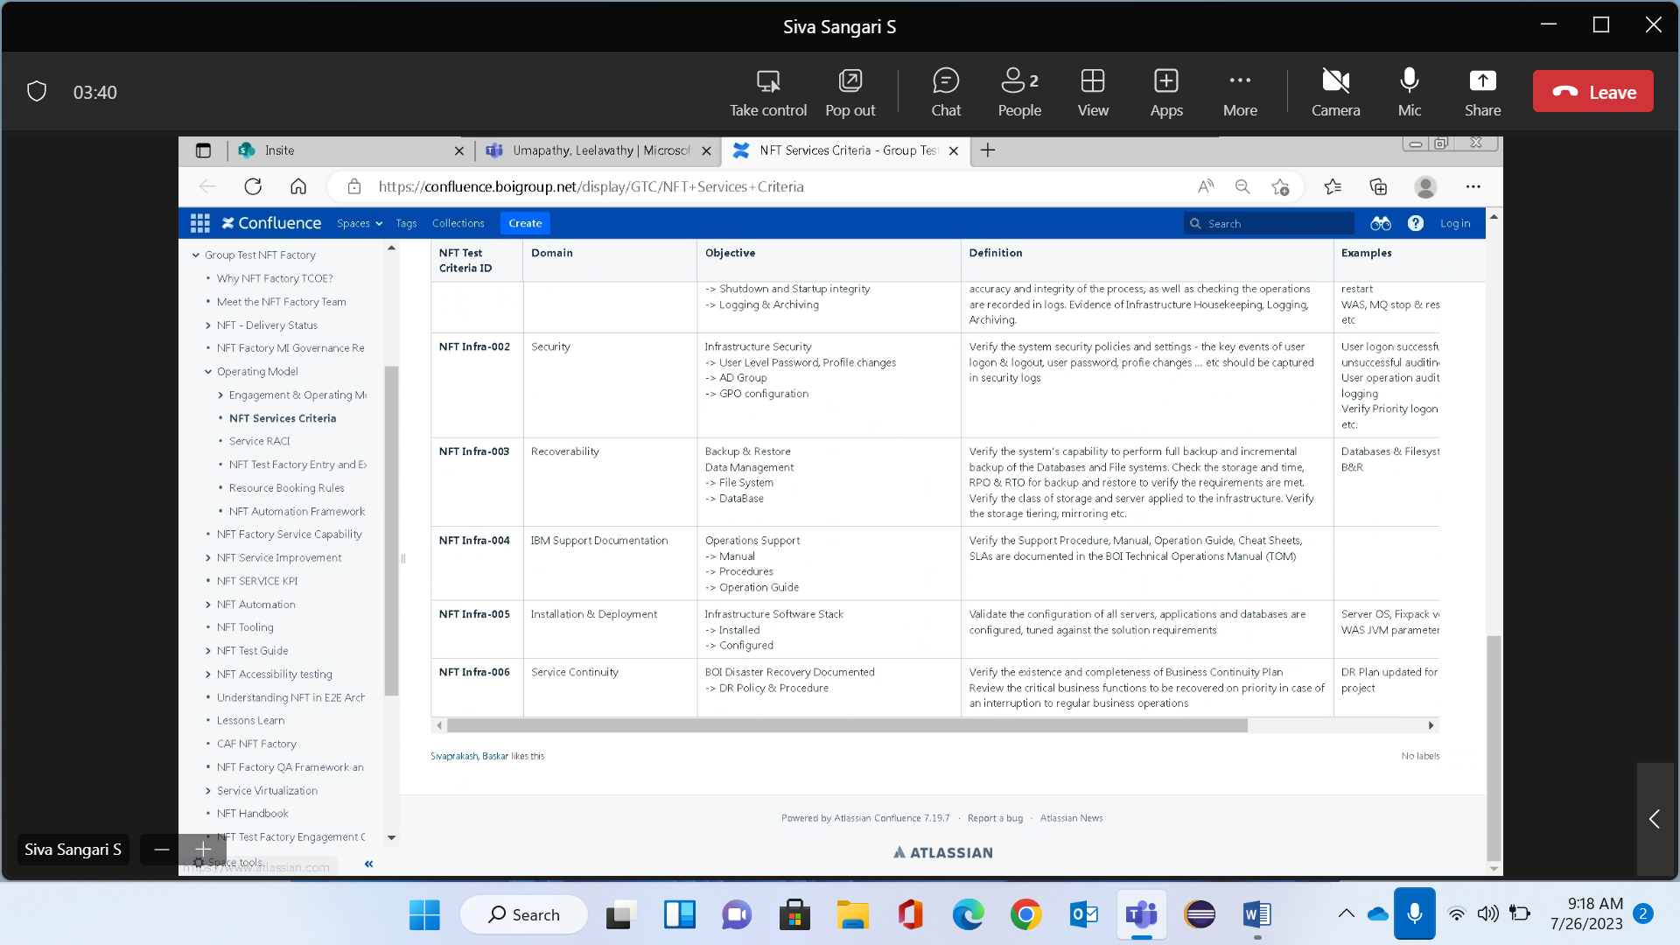

performance testing

https://www.softwaretestinghelp.com/hp-loadrunner-load-testing-tool-training-tutorials/

https://www.softwaretestinghelp.com/loadrunner/vugen-script-loadrunner/

<https://www.guru99.com/operational-testing.html>

<https://www.guru99.com/understanding-vugen-in-loadrunner.html>

linux commands ish